Automated Network Request Management in ServiceNow
Project Report
SkillWallet project submission

Item | Details
Platform | ServiceNow — ServiceNow Personal Developer Instance (development environment, not production)
Instance | https://dev427931.service-now.com
Team ID | [Team ID]
Team members & roles | [Team Leader / Team Members — names and roles]
Institution / Program | [Institution and program name]
Faculty guide / Mentor | [Name, if applicable]
GitHub repository | https://github.com/pavan-kalyan-pk-2646/servicenow-network-request-automation.git
Project demo (Drive folder) | https://drive.google.com/drive/folders/1PAaBuybnLuN8JptoJ27fXBuDrTUFdcjM?usp=sharing
Submission date | [DD Month YYYY]
Document version | 1.2 (development instance build — screenshot evidence and project links added)

Table of Contents
Right-click and choose Update Field to refresh the table of contents.

1. INTRODUCTION

1.1 Project Overview
Automated Network Request Management in ServiceNow is a ServiceNow solution for raising, recording, approving and fulfilling network service requests. Users submit a request through the Network Request catalog item (category Network, short description 'Network Services Request'). The form captures the connection details, shows the existing-connection ID field only when an Existing connection is selected, and includes the 'Requester Information' variable set.
Processing is automated by the Flow Designer flow 'Network Request Automation' (Global scope). The flow uses a Service Catalog trigger, so it starts when the Network Request item is requested. It retrieves the catalog variables, creates a record in the custom table Database Tables (u_database_table), generates an email notification, asks for approval, evaluates the decision and updates the record in the approved (then) or Else branch. The Network Team then works and closes the catalog task.
The work was built and tested on a ServiceNow Personal Developer Instance (https://dev427931.service-now.com). It has not been deployed to a production instance. Ten screenshots from the instance are included as evidence (Section 7.1 lists them all), and every open defect is reported in Section 6.

1.2 Purpose
- Replace informal, manual handling of network requests with a single structured intake channel.
- Capture complete, relevant request details and reduce repeated data entry.
- Store every request as a record with a clear approval status.
- Automate approval routing and the status update that follows the decision.
- Generate an acknowledgement notification for the requester.
- Support fulfilment and closure of the catalog task by the Network Team.
- Document the implementation, its testing evidence and its known limitations accurately.

2. IDEATION PHASE

2.1 Problem Statement
Table 1: Customer problem statements
PS | I am (Customer) | I'm trying to | But | Because | Which makes me feel
PS-1 | a user who needs a new or existing network connection | request the service with correct details and know its status | my request goes by phone or email, I repeat my details and don't know if it is approved | there is no structured intake form linked to an automated record, approval and notification process | frustrated and uncertain
PS-2 | a Network Team member / approver | review, approve and fulfil requests quickly and accurately | requests arrive incomplete and I re-enter them and chase approvals | requests are not captured in a record connected to an approval and a fulfilment task | overloaded and worried about errors

2.2 Empathy Map Canvas
The empathy map below was prepared by the team from its analysis of the manual process; it is not based on formal user interviews.
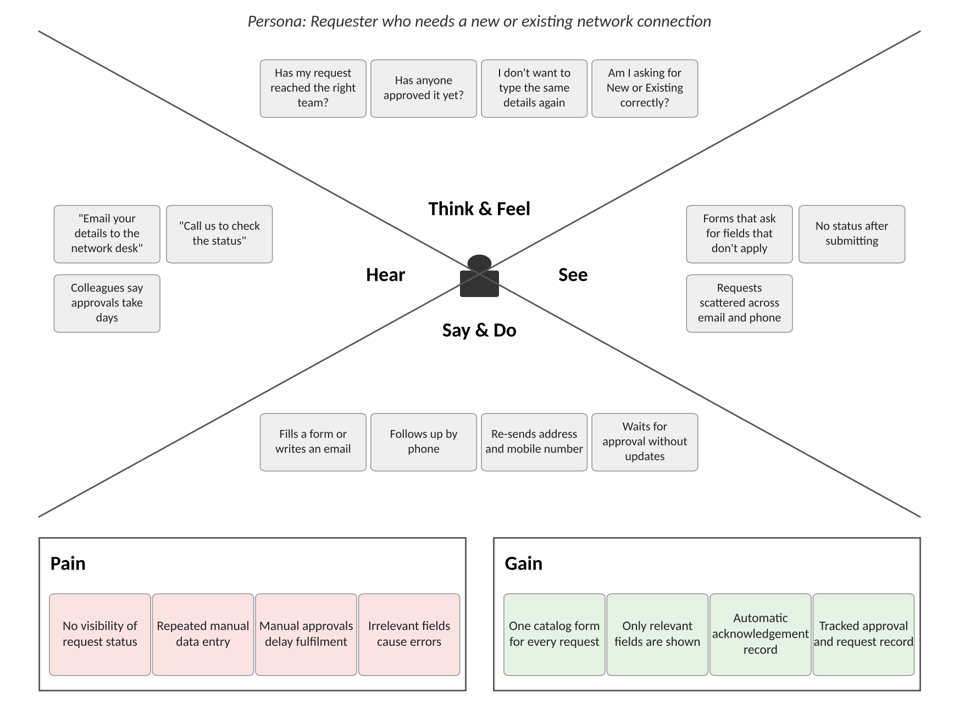
Figure 1: Empathy map — network service requester

2.3 Brainstorming
Eighteen ideas were generated, grouped into five themes and prioritised by importance and feasibility. Ideas I1–I10 were implemented; the remaining ideas are recorded as future scope.
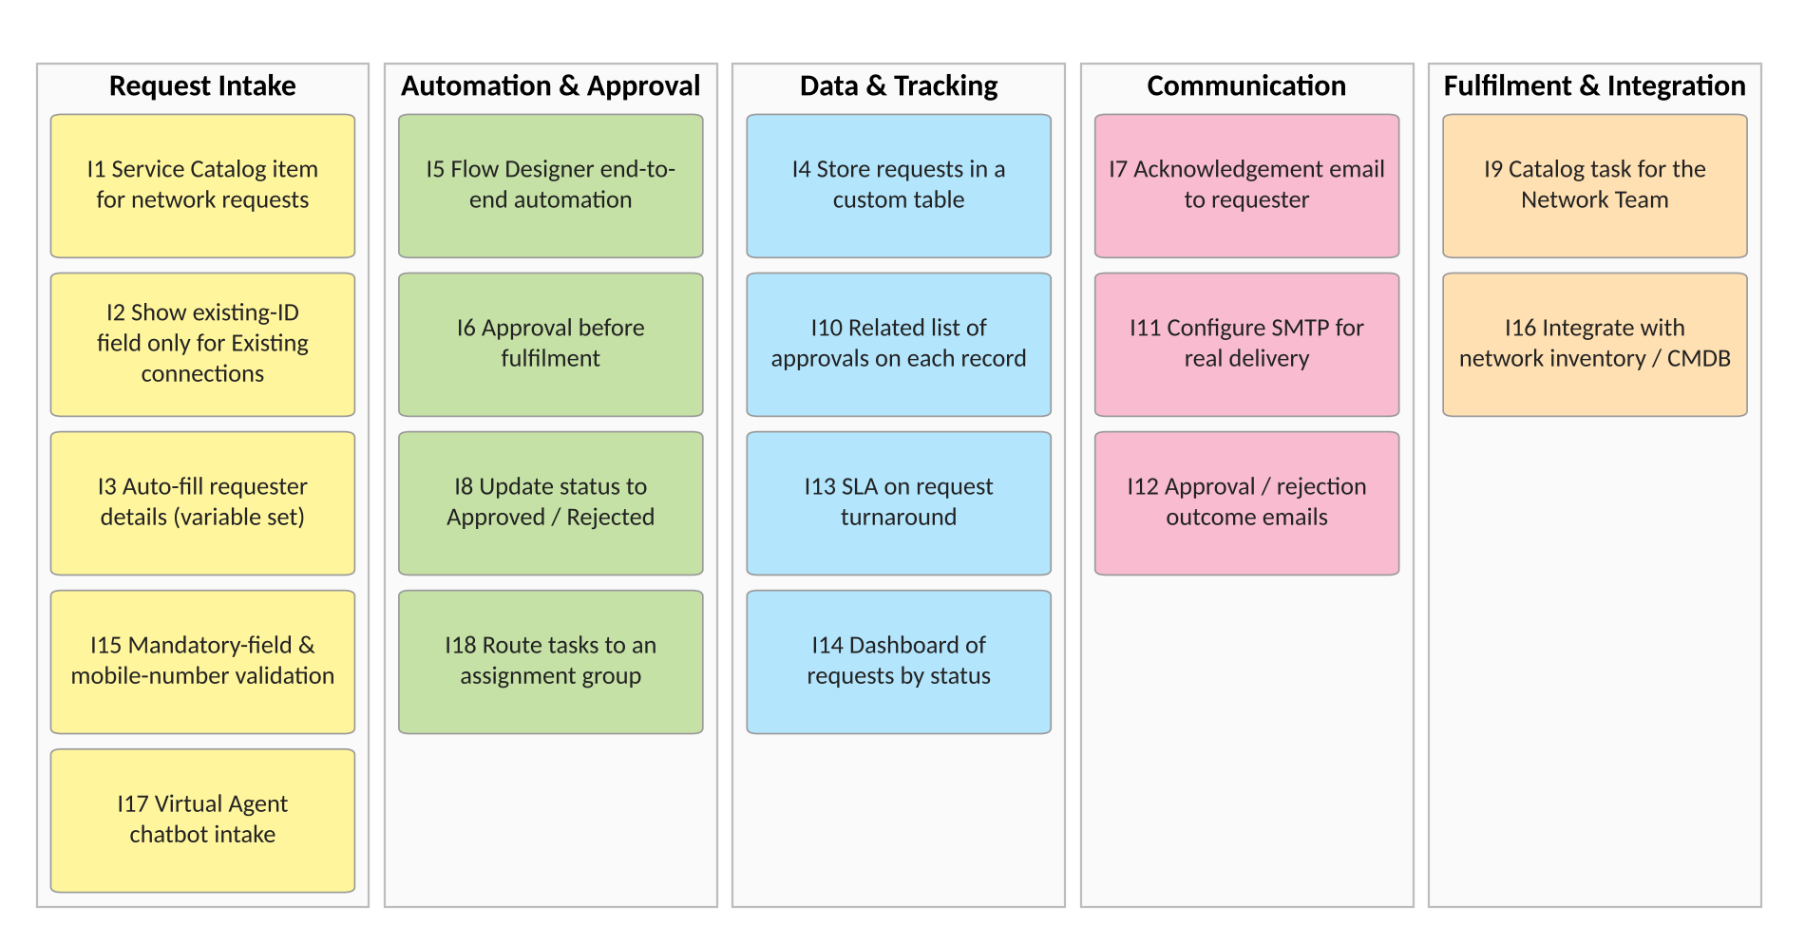
Figure 2: Brainstormed ideas grouped by theme
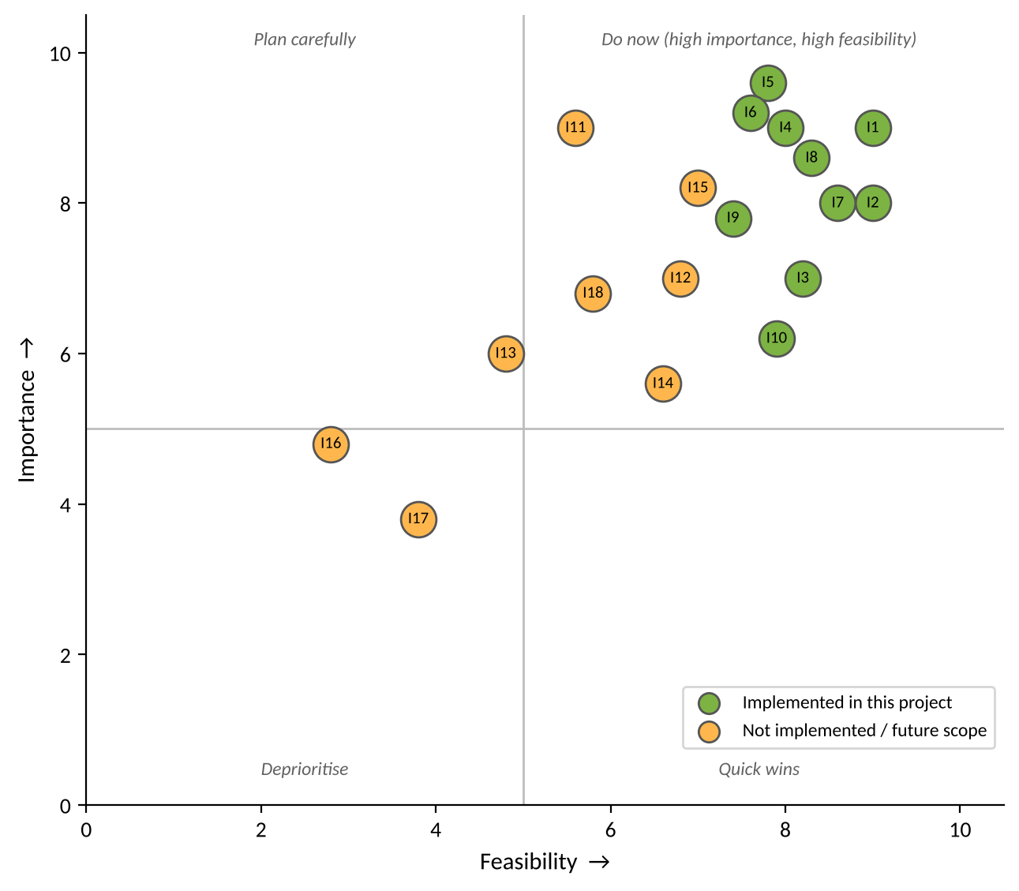
Figure 3: Idea prioritisation — implemented vs future scope

3. REQUIREMENT ANALYSIS

3.1 Customer Journey Map
Table 2: Customer journey map (summary; full map in the Requirement Analysis deliverable)
Stage | Steps | Positive | Negative / Opportunity
Entice | Needs a connection; finds Network Request in the Service Catalog / Portal. | One known place to ask. | Unsure which item to use → clear category and description.
Enter | Opens Network Request; selects New or Existing; fills mandatory fields. | Existing-ID field shown only for Existing. | Phone Number not pre-filled in testing → verify population; add validation.
Engage | Orders (e.g. REQ0010004); the flow creates the record, the email record and the approval. | No manual hand-off. | Stored values incorrect (BG-03); email not delivered without SMTP.
Exit | Approver approves; record Approved; catalog task Closed Complete. | Decision captured on the record. | Rejected path untested; no outcome email.
Extend | Past requests reviewed. | Each request stored with a status. | No dashboard or SLA → reports and SLA.

3.2 Solution Requirement
Table 3: Functional requirements
FR No. | Functional Requirement (Epic) | Sub Requirement (Story / Sub-Task)
FR-1 | Network Service Request Intake | Publish the Network Request item in the Service Catalog (Category: Network, short description 'Network Services Request')  Capture Requested For, Mobile Number, Type of Connection, Enter your existing id, Total Amount, Mode of Payment (UPI / CARD) and Address  Generate a request record on submission
FR-2 | Requester Information | Provide the 'Requester Information' variable set (Opened on behalf of, Email, User Name, Phone Number)  Populate Email and User Name from the referenced user  Populate Phone Number (not populating for System Administrator — requires verification)
FR-3 | Dynamic Field Visibility | Show 'Enter your existing id' when Type of Connection = Existing (UI Policy 'Show existing ID field', On load, Reverse if false)  Hide the field when Type of Connection = New
FR-4 | Request Data Storage | Store each request in the custom table Database Tables (u_database_table)  Store the submitted Address, Mobile Number, Requested For, Type of Connection, Mode of Payment and Total Amount  Record the approval outcome in Approval Status
FR-5 | Workflow Automation | Trigger the 'Network Request Automation' flow when the Network Request item is requested (Service Catalog trigger)  Retrieve catalog variables with Get Catalog Variables  Create the Database Tables record with the submitted values
FR-6 | Email Notification | Generate an email with subject 'Network Request Received - Pending Approval' and the configured body  Create an outbound email record targeted at the Database Tables record  Deliver the email externally (requires an active SMTP account — not configured)
FR-7 | Approval Management | Request approval through Ask For Approval on Database Tables (Approval Field: Approval Status)  Apply the rule 'Approve when anyone approves' with System Administrator as approver  Show related approvals on the record through the 'Approval Request' relationship
FR-8 | Decision Processing | Evaluate 'If Request is Approved'  Update Approval Status in the Approved branch  Update Approval Status in the Else (rejected) branch — to be tested
FR-9 | Fulfilment and Closure | Allow the Network Team to work on the catalog task  Close the catalog task with state Closed Complete

Table 4: Non-functional requirements
NFR No. | Requirement | Description
NFR-1 | Usability | Requests are raised through the standard catalog form. Only relevant fields are shown (UI Policy), mandatory fields are marked with an asterisk, and requester details can be pre-filled by the variable set.
NFR-2 | Security | Access is governed by ServiceNow authentication and roles. Approval is restricted to the configured approver. No table-specific access controls (ACLs) are listed for u_database_table (BG-04), and access behaviour for non-admin users has not been tested. No credentials are included in this documentation.
NFR-3 | Reliability | Each run is recorded as a Flow Designer execution with per-step state and duration, so failures can be traced. Known issues: the Create Record mapping stores variable names instead of values (BG-03), and external email delivery depends on SMTP (BG-02).
NFR-4 | Performance | In one test run, the automated steps completed in milliseconds (e.g. Get Catalog Variables 98 ms, Create Record 152 ms, Send Email 925 ms). End-to-end time is dominated by the human approval. No load testing has been performed.
NFR-5 | Availability | The solution runs on a ServiceNow-hosted Personal Developer Instance. Developer instances can hibernate when inactive, so availability is suitable for development and demonstration, not for production use.
NFR-6 | Scalability | Additional catalog items, approvers, approval rules and flow branches can be added by configuration. The solution is built in the Global scope; packaging as a scoped application is recommended before wider rollout.

3.3 Data Flow Diagram
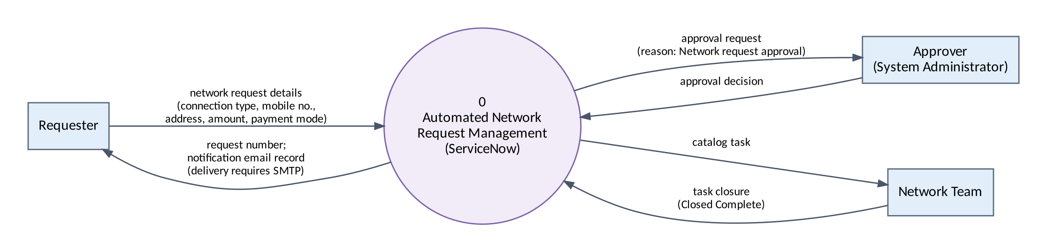
Figure 4: DFD Level 0 — context diagram
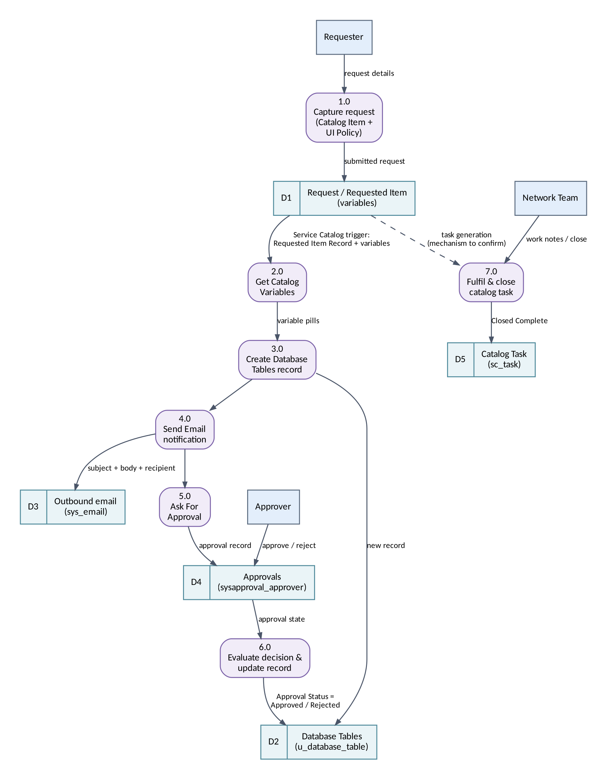
Figure 5: DFD Level 1 — processes and data stores (dashed: catalog-task generation, not covered by evidence)
Table 5: User stories
User Type | Story No. | User Story | Priority | Release
Requester | USN-1 | As a requester, I can find the Network Request item in the Service Catalog under the Network category. | High | Sprint-1
Requester | USN-2 | As a requester, I can enter Requested For, Mobile Number, Type of Connection, Total Amount, Mode of Payment and Address and submit the request. | High | Sprint-1
Requester | USN-3 | As a requester, my Email and User Name are filled automatically from the Requester Information variable set. | Medium | Sprint-1
Requester | USN-4 | As a requester, I see the 'Enter your existing id' field only when I choose an Existing connection. | High | Sprint-1
Administrator | USN-5 | As an administrator, each network request is stored in the Database Tables (u_database_table) table. | High | Sprint-1
Approver | USN-6 | As an approver, I can see the approval records that belong to a Database Tables record. | Medium | Sprint-1
Administrator | USN-7 | As an administrator, the Network Request Automation flow starts automatically when the Network Request item is requested and retrieves the catalog variables. | High | Sprint-2
Administrator | USN-8 | As an administrator, the flow creates a Database Tables record from the submitted catalog values. | High | Sprint-2
Requester | USN-9 | As a requester, I am notified that my request has been received and is pending approval. | Medium | Sprint-2
Approver | USN-10 | As an approver, I receive an approval request for every new network request. | High | Sprint-2
Administrator | USN-11 | As an administrator, the request status is updated to Approved or Rejected according to the decision. | High | Sprint-2
Network Team | USN-12 | As a Network Team member, I can work on and close the catalog task for the request. | Medium | Sprint-3
Administrator | USN-13 | As the project team, we test the end-to-end process and capture evidence for each test case. | High | Sprint-3
Project Team | USN-14 | As the project team, we prepare documentation, a demonstration video and a GitHub submission. | Medium | Sprint-3

3.4 Technology Stack
Table 6: Technology stack
Component | Technology used
User interface | ServiceNow Service Catalog / Service Portal — catalog item 'Network Request', 7 variables, variable set 'Requester Information'
Client-side logic | Catalog UI Policy 'Show existing ID field'
Workflow automation | Flow Designer (Workflow Studio) flow 'Network Request Automation' — Service Catalog trigger, Global scope
Approval | Ask For Approval on Database Tables; relationship 'Approval Request' (server-side JavaScript query)
Database | Custom table u_database_table (16 columns) plus standard request, requested item, task, approval and email tables
Notification | ServiceNow email (outbound email record, notification type SMTP). No active SMTP account.
External APIs / ML / file storage | Not used
Infrastructure | ServiceNow-hosted Personal Developer Instance (https://dev427931.service-now.com)

4. PROJECT DESIGN

4.1 Problem Solution Fit
Table 7: Problem–solution fit summary
Canvas block | Summary
Customer segments | Users needing new or existing network connections; Network Team and approvers.
Jobs / problems | Request with correct details, get approval and fulfilment, know the status.
Root cause | No single structured intake channel connected to a record, an approval and a task.
Behaviour | Re-sending details, phone/email follow-ups, manual re-keying and approval chasing.
Constraints | Must work in ServiceNow; needs an authorised approver; email needs SMTP.
Your solution | Network Request catalog item + UI Policy + variable set + Network Request Automation flow + approval relationship + catalog task closure.
Emotions | Before: uncertain, frustrated. After: confident and informed.

4.2 Proposed Solution
Table 8: Proposed solution
Parameter | Description
Problem to be solved | Manual, untracked network requests with incomplete details and manual approvals.
Idea / solution | Catalog item with dynamic fields; a Service Catalog-triggered flow that records, notifies, approves and updates the status; catalog task closure.
Novelty / uniqueness | End-to-end low-code automation; existing-ID field shown only when needed; filtered approval related list.
Social impact / customer satisfaction | Simpler requesting and a clear approval trail; acknowledgement email once SMTP is configured.
Business model | Internal IT service; value through efficiency rather than revenue.
Scalability | Configurable on the ServiceNow cloud; scoped app, SMTP, approval groups and ACLs needed before production.

4.3 Solution Architecture
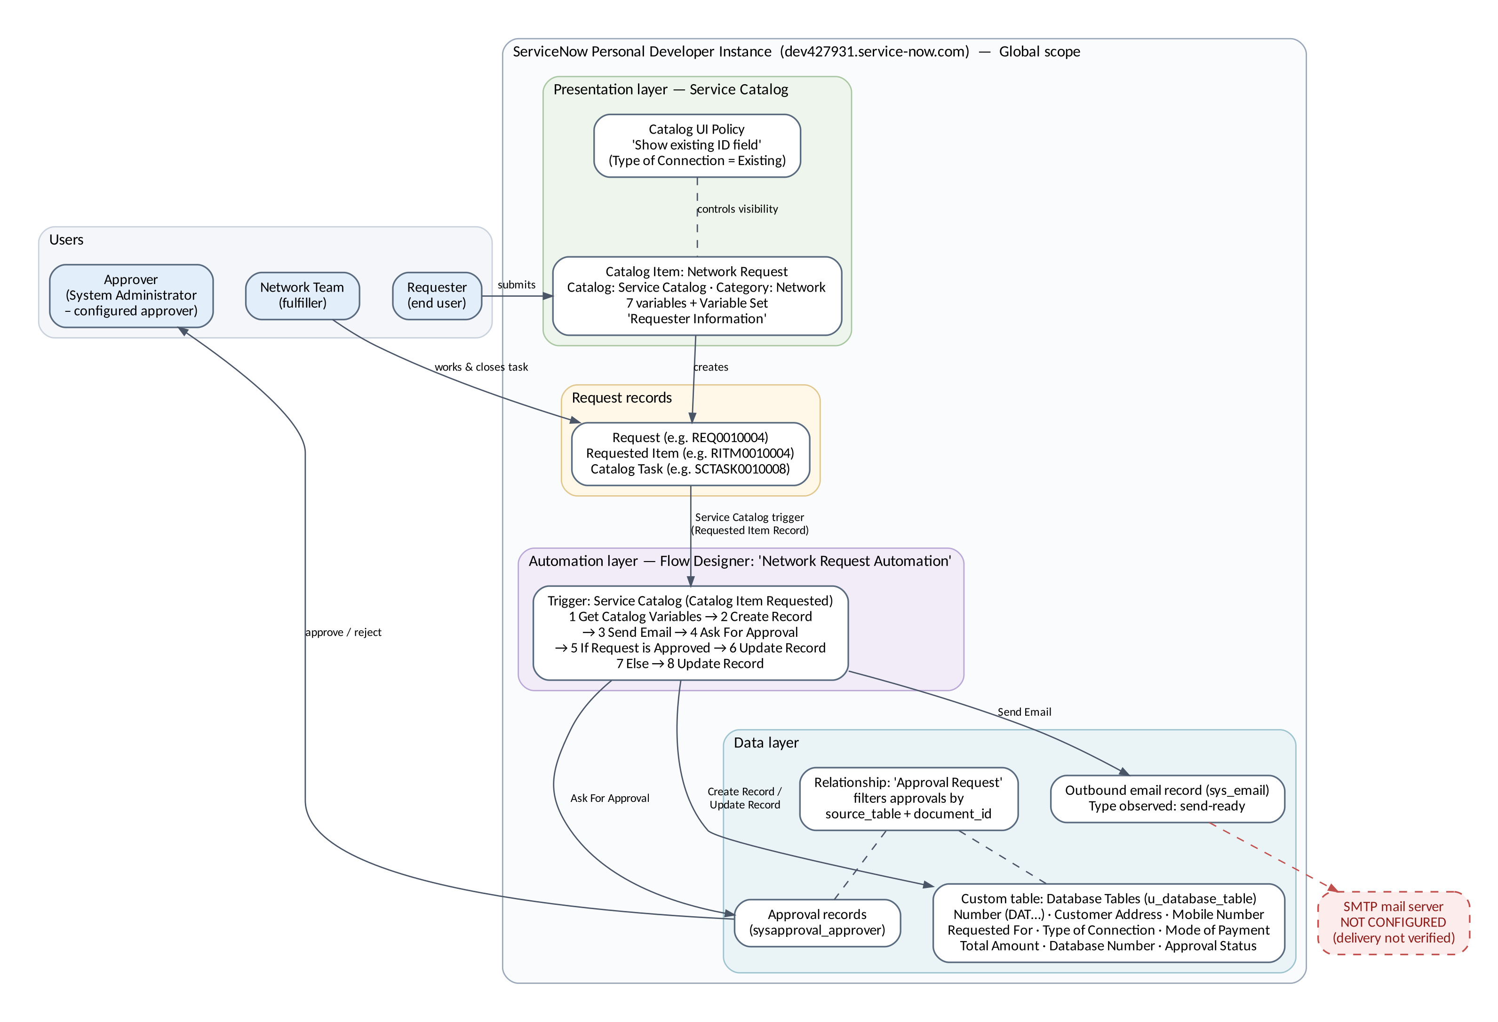
Figure 6: Solution architecture

4.3.1 User roles and responsibilities
Table 9: User roles
Role | Responsibilities in this solution
Requester | Opens the Network Request item, enters the connection details and orders the item.
Approver (System Administrator — configured approver) | Approves or rejects the approval generated by Ask For Approval.
Network Team (fulfiller) | Works on and closes the catalog task (e.g. SCTASK0010008 — Closed Complete).
ServiceNow administrator / developer | Maintains the catalog item, variables, UI Policy, table, relationship and flow.

4.3.2 ServiceNow components used
Table 10: ServiceNow components
Component | Name / configuration | Purpose
Catalog item | Network Request — category Network, 'Network Services Request' | Single intake form
Catalog variables | 7 variables (Section 4.3.3) | Capture request details
Variable set | Requester Information | Requester details
Catalog UI Policy | Show existing ID field | Dynamic visibility of the existing-ID field
Custom table | Database Tables (u_database_table), Global | Store each request and its approval status
Relationship | Approval Request | Related list of approvals for a record
Flow | Network Request Automation — Service Catalog trigger, Global, Active | Automate record creation, email, approval and status update
Email | Send Email action → outbound email record | Acknowledge the request (delivery needs SMTP)
Catalog task | e.g. SCTASK0010008 (RITM0010004) | Fulfilment and closure

4.3.3 Catalog item, variables and variable set
The Network Request item appears in the Service Portal with its short description 'Network Services Request', and the My Requests widget lists the requests submitted from it (Screenshot 1). The form opens at Network > Network Request. Six variables are mandatory (marked *); 'Enter your existing id' is optional and shown only for Existing connections (Screenshots 2 and 3).
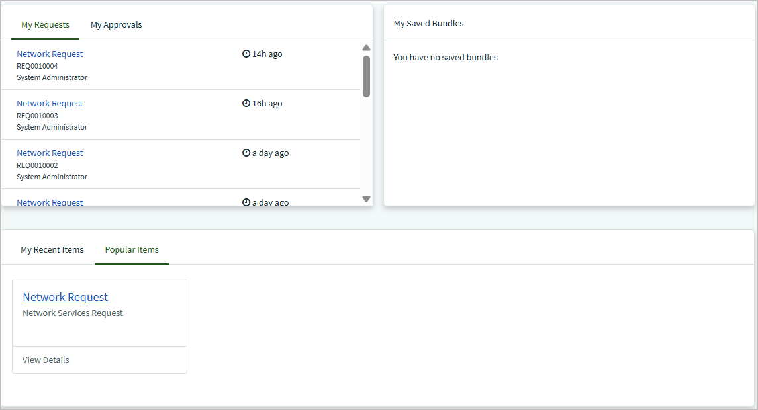
Screenshot 1: Service Portal — Network Request in Popular Items ('Network Services Request') and My Requests listing REQ0010004, REQ0010003 and REQ0010002
Table 11: Catalog item variables
Variable | Setting (from the form) | Purpose
Requested For | Mandatory (*) | Person for whom the network service is requested.
Mobile Number | Mandatory (*) | Contact number of the requester.
Type of Connection | Mandatory (*); choice New / Existing | Drives the UI Policy 'Show existing ID field'.
Enter your existing id | Optional; shown only for Existing | Identifier of the existing connection.
Total Amount | Mandatory (*) | Amount associated with the requested service.
Mode of Payment | Mandatory (*); choice UPI / CARD | Payment method chosen by the requester.
Address | Mandatory (*) | Service / installation address.

The 'Requester Information' variable set appears at the top of the form with four fields (Screenshots 2 and 3). The tester observed that Email and User Name populate once a user is selected in 'Opened on behalf of', but Phone Number did not populate for the System Administrator account. The cause has not been confirmed.
Table 12: Variable set 'Requester Information'
Variable | Observed behaviour
Opened on behalf of | User reference used to populate the requester details.
Email | Reported by the tester as populated from the referenced user (not captured in the screenshots).
User Name | Reported by the tester as populated from the referenced user (not captured in the screenshots).
Phone Number | Did NOT populate for the System Administrator account during testing (requires verification).

4.3.4 UI Policy and dynamic field visibility
The Catalog UI Policy 'Show existing ID field' (Screenshot 4) applies to the Network Request catalog item in the Global application and is Active. Its condition is type_of_connection is Existing. It applies on the Catalog Item view (not on Catalog Tasks or Requested Items), runs On load, and has Reverse if false enabled. Its single action sets enter_your_existing_id to Visible = True, with Read only and Mandatory left alone. Because of 'Reverse if false', the field is hidden when the condition is false (New), as Screenshots 2 and 3 show. Mandatory is left alone, so the policy does not make the existing ID required (TC-20).
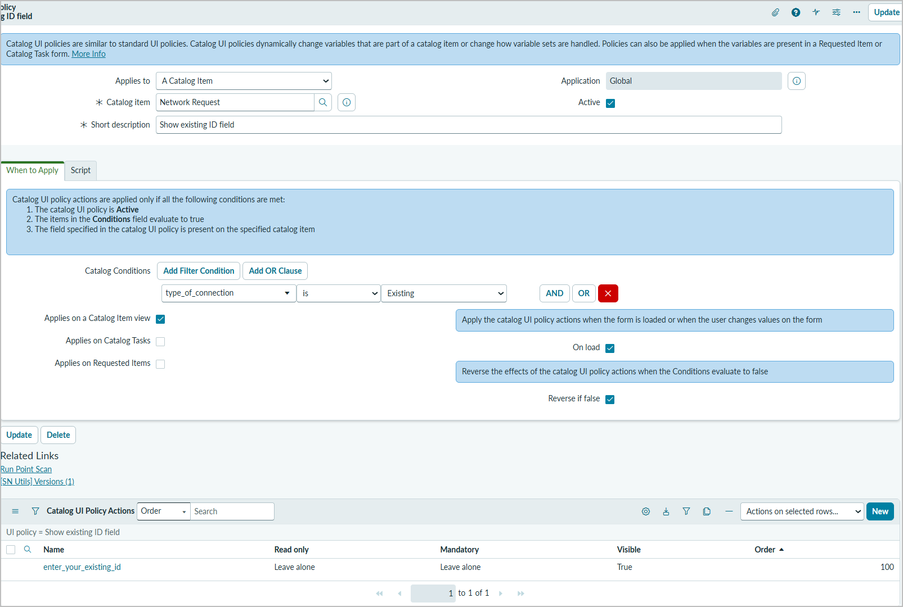
Screenshot 4: Catalog UI Policy 'Show existing ID field' — condition type_of_connection is Existing; On load and Reverse if false enabled; action Visible = True
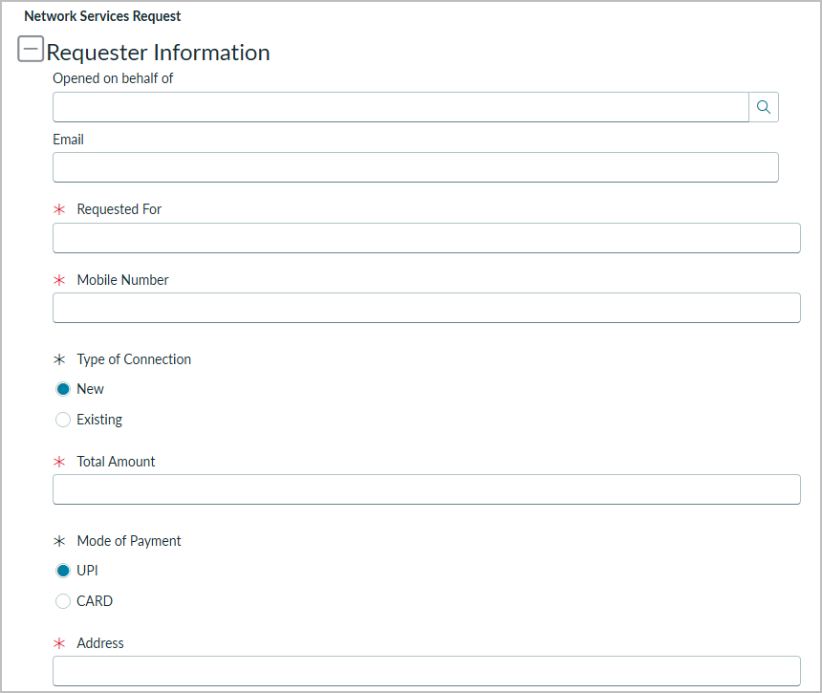
Screenshot 2: Network Request form with Type of Connection = New — 'Enter your existing id' is hidden
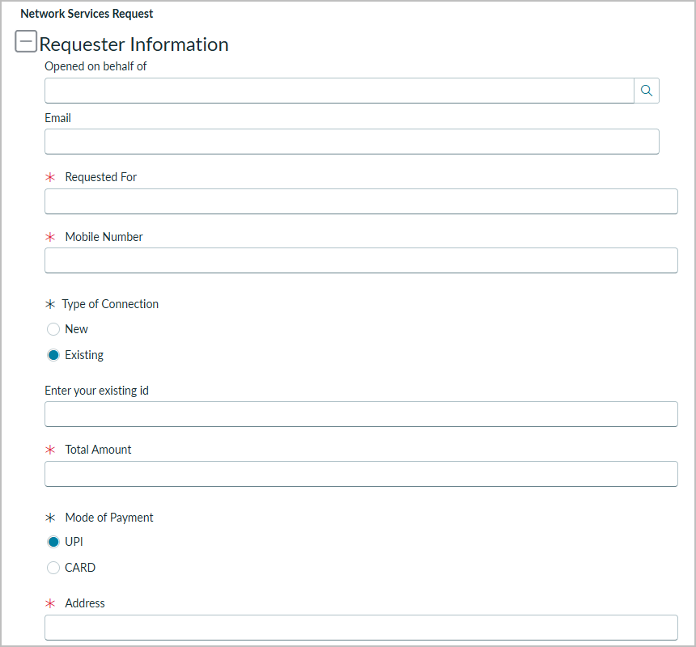
Screenshot 3: Network Request form with Type of Connection = Existing — 'Enter your existing id' is visible; mandatory variables marked *

4.3.5 Custom table and record structure
The custom table Database Tables (technical name u_database_table, Global application) has 16 columns (Screenshot 5). Records are numbered by the Number field, whose default javascript:global.getNextObjNumberPadded() generates DAT numbers (for example DAT0001016, the target of the email record). All request fields are String columns; Assignment to is a reference to User.
Table 13: Database Tables columns (from the table definition)
Column | Type | Reference | Notes
Number | String | — | Default javascript:global.getNextObjNumberPadded() → DAT numbers (e.g. DAT0001016)
Database Number | String | — | Custom field; populated by Create Record
Customer Address | String | — | Populated by Create Record
Mobile Number | String | — | Populated by Create Record
Requested For | String | — | Populated by Create Record
Type of Connection | String | — | Populated by Create Record
Mode of Payment | String | — | Populated by Create Record
Total Amount | String | — | Populated by Create Record
Approval Status | String | — | Approval Field of Ask For Approval; values observed: Pending, Approved, requested
Assignment to | Reference | User [sys_user] | Empty in all observed records
System fields | Sys ID, Created, Created by, Updated, Updated by, Updates | — | Standard ServiceNow columns

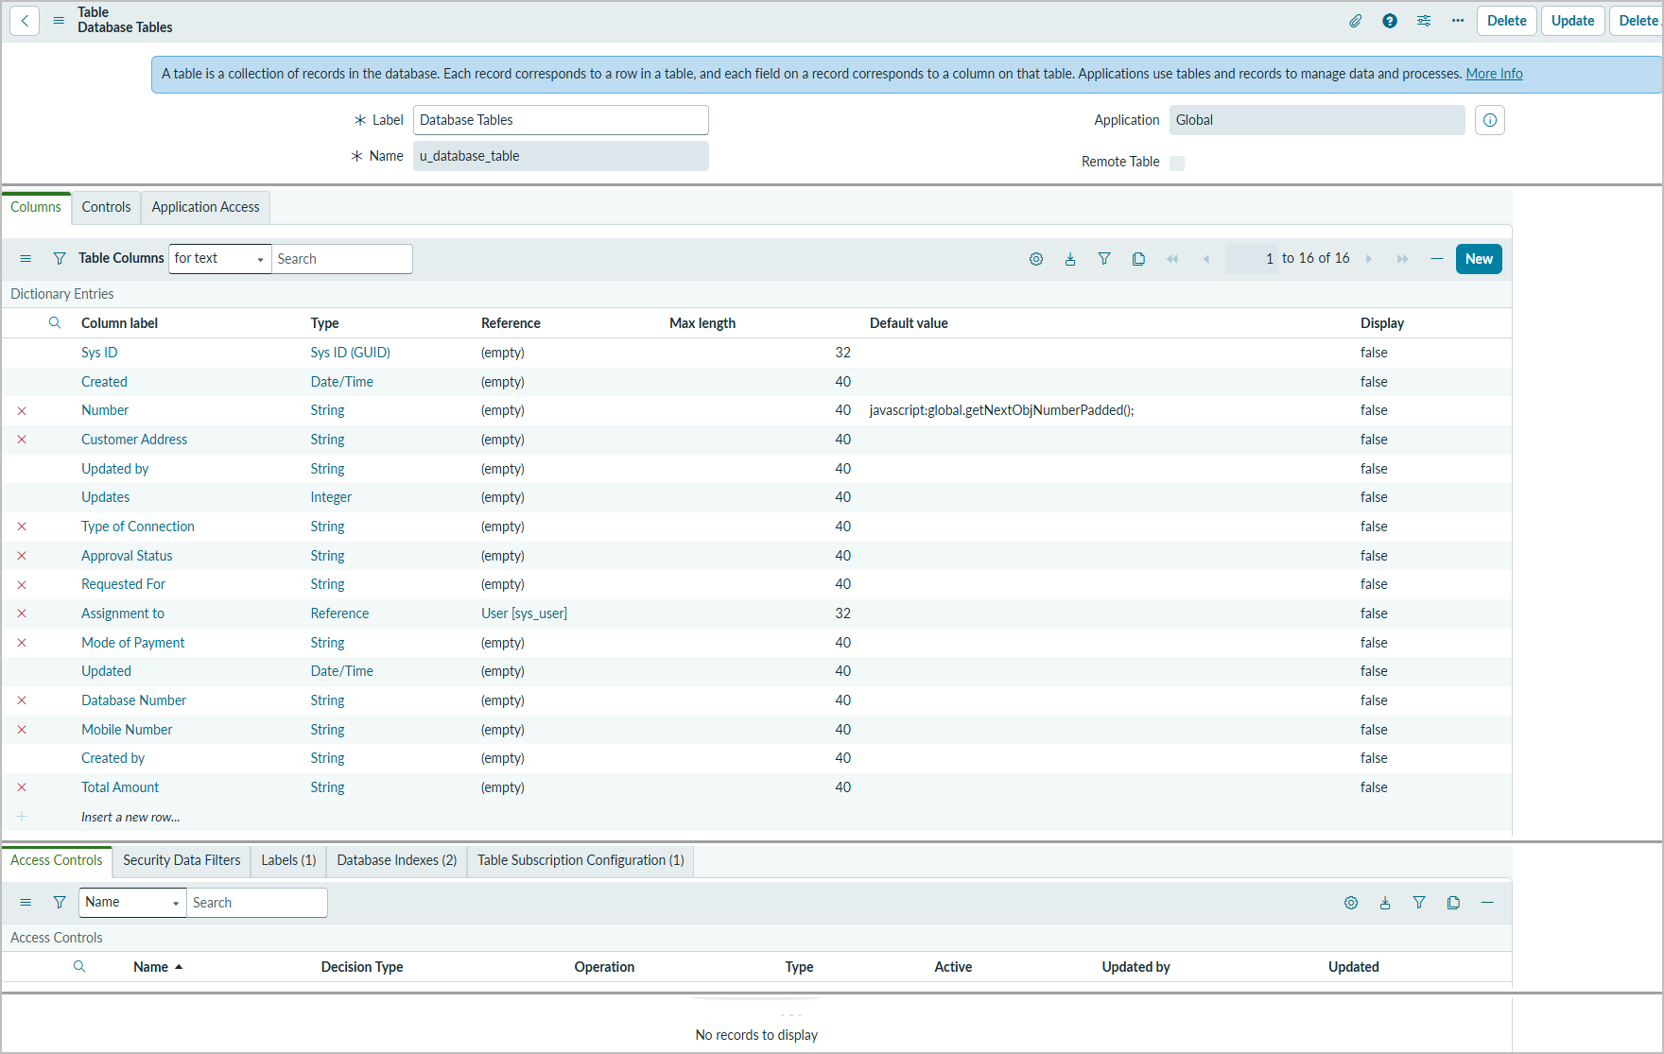
Screenshot 5: Table definition Database Tables (u_database_table) — 16 columns; Access Controls list empty
Observations: the Access Controls list for the table is empty, so no table-specific ACLs are defined (BG-04). Approval Status is free text, and the observed values are inconsistent: Pending, Approved, requested (BG-05).

4.3.6 Approval relationship and reference filtering
A Relationship named 'Approval Request' provides a related list of approval records on the Database Tables form. Its query script is:
(function refineQuery(current, parent) {
current.addQuery('source_table', parent.getTableName());
current.addQuery('document_id', parent.sys_id);
})(current, parent);
ServiceNow calls refineQuery when the related list is displayed. 'current' is the query on the related (approval) records and 'parent' is the Database Tables record being viewed. The first condition keeps only approvals whose source_table equals the parent's table name (u_database_table). The second keeps only approvals whose document_id equals the parent record's sys_id. The related list therefore shows only the approvals raised for that specific record. The related list has not yet been tested (TC-16).

4.3.7 Flow Designer trigger and actions
Screenshot 6 shows the flow 'Network Request Automation' in Workflow Studio (Active, Global). The trigger is Service Catalog, and its data pills are Requested Item Record, Table Name, Run Start Time UTC and Run Start Date/Time. Step 1 reads the requested item's variables, and their pills (type_of_connection, enter_your_existing_id, requested_for, mobile_number, total_amount, mode_of_payment, address, email) are available to the later steps. The status bar shows 'Status: Draft', so the published version should be confirmed before submission.
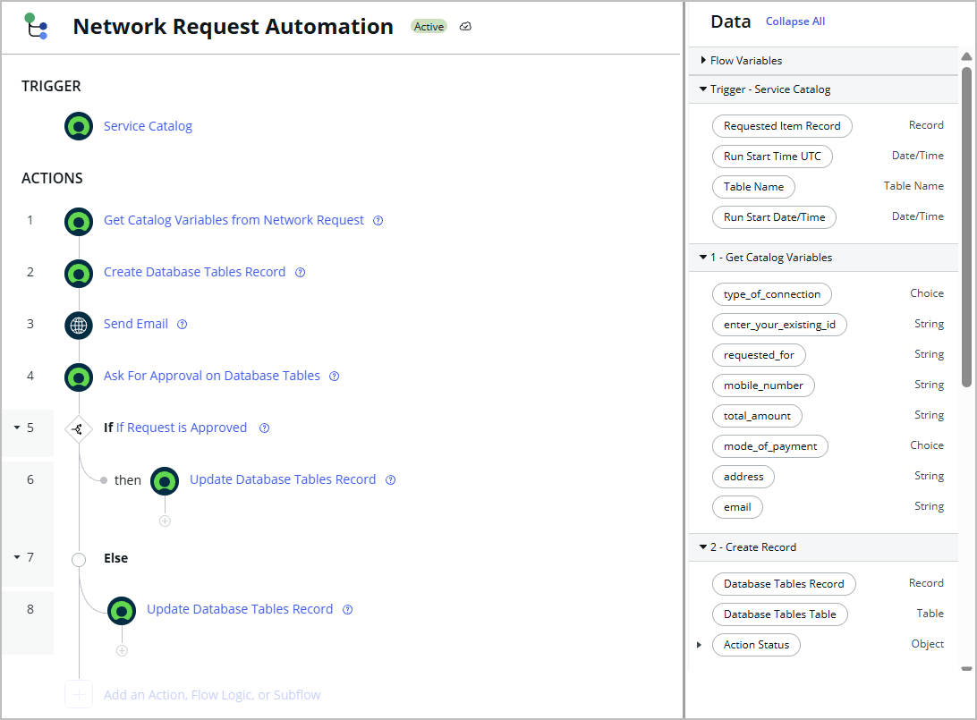
Screenshot 6: Flow 'Network Request Automation' (Active, Global) — Service Catalog trigger, actions 1–8 and data pills (empty middle area of the screen removed)
Table 14: Flow 'Network Request Automation' — trigger and actions
Step | Action | Purpose | Inputs, outputs and test-run result
Trigger | Service Catalog (execution label: Catalog Item Requested) | Starts the flow when the Network Request catalog item is requested. | Outputs: Requested Item Record, Table Name, Run Start Time UTC, Run Start Date/Time.
1 | Get Catalog Variables from Network Request | Reads the variables submitted on the requested item. | Input: Requested Item Record (trigger). Outputs: type_of_connection (Choice), enter_your_existing_id, requested_for, mobile_number, total_amount, mode_of_payment (Choice), address, email. Test run: Completed, 98 ms.
2 | Create Database Tables Record | Creates the Database Tables record that represents the request. | Fields populated: Customer Address, Mobile Number, Mode of Payment, Requested For, Total Amount, Type of Connection, Database Number, Approval Status. Output: Database Tables Record. Test run: Completed, 152 ms. Defect BG-03: stored values are variable names, not submitted values.
3 | Send Email | Generates the acknowledgement email with subject 'Network Request Received - Pending Approval'. | Email record target: the Database Tables record (observed: DAT0001016). Test run: Completed, 925 ms. Delivery depends on SMTP (not configured).
4 | Ask For Approval on Database Tables | Requests approval of the network request. | Approval Field: Approval Status; Reason: Network request approval; Rule: Approve when anyone approves; Approver: System Administrator (as reported by the project owner; the step configuration is not visible in the screenshots). Test run: Completed (action start 21:55:27).
5 | If Request is Approved | Evaluates the approval outcome. | Test run: Evaluated — True at 21:58:24 (288 ms).
6 | Update Database Tables Record (then) | Approved branch: sets Approval Status to Approved. | Test run: Completed (288 ms).
7 | Else | Branch taken when the request is not approved. | Test run: Not Run.
8 | Update Database Tables Record (Else) | Rejected branch: updates Approval Status for a rejected request. | Test run: Not Run — rejected path not yet tested.

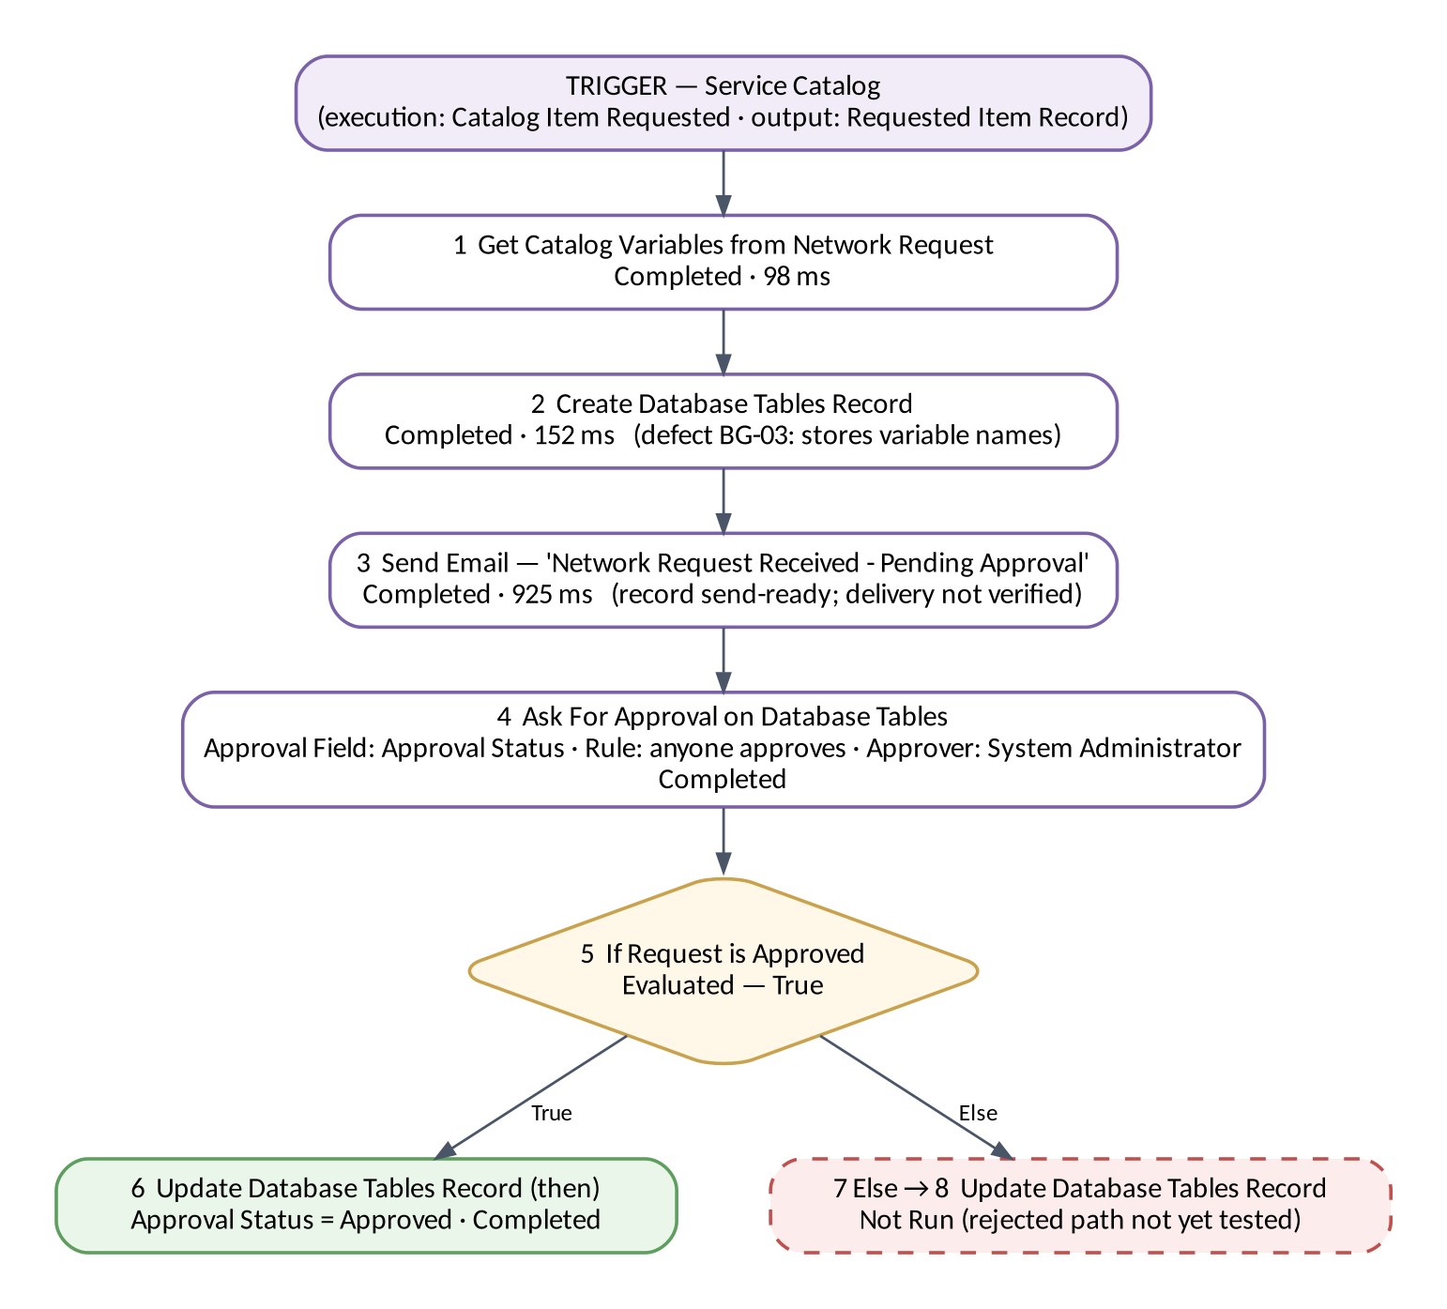
Figure 7: Flow execution path with test-run results
4.3.7.1 Create Record mapping review (defect BG-03)
Defect found. Step 2 completed in the test run, but the flow-created records in Screenshot 8 hold the literal variable names (address, mobile_number, type_of_connection, requested_for, mode_of_payment, total_amount) instead of the values entered on the form. Database Number holds the text 'Trigger → Service Catalog → Requested It…'. This matches field values that were entered as plain text instead of as data pills. The variable names and column names below are taken from Screenshots 5 (table columns), 6 (data pills) and 8 (stored values).
Table 15: Create Record mapping — observed values and recommended correction
u_database_table column | Value stored (observed) | Recommended mapping (data pill)
Customer Address | address | 1 - Get Catalog Variables → address
Mobile Number | mobile_number | 1 - Get Catalog Variables → mobile_number
Type of Connection | type_of_connection | 1 - Get Catalog Variables → type_of_connection (Choice)
Requested For | requested_for | 1 - Get Catalog Variables → requested_for
Mode of Payment | mode_of_payment | 1 - Get Catalog Variables → mode_of_payment (Choice)
Total Amount | total_amount | 1 - Get Catalog Variables → total_amount
Database Number | Trigger → Service Catalog → Requested It… (text) | Intended source not documented. If it should hold the request reference: Trigger - Service Catalog → Requested Item Record → Number
Approval Status | Approved / requested | Set one consistent initial value (e.g. Requested); Ask For Approval writes the approval state to this field

- enter_your_existing_id and email have no matching column in u_database_table, so they are not stored.
- Choice pills (type_of_connection, mode_of_payment) pass the choice value, which may differ from the label shown on the form; check the stored values after the fix.
Recommended correction (not yet applied or retested):
1. Open Workflow Studio → Network Request Automation → Edit flow.
2. Open step 2 'Create Database Tables Record'.
3. For each field in the table above, clear the typed text and drag the matching data pill from the Data panel (section '1 - Get Catalog Variables'), so the field shows a pill, not plain text.
4. Decide what Database Number should contain and map it accordingly.
5. Save, then Activate / publish the flow (the status bar currently shows 'Status: Draft').
6. Retest: order Network Request with distinct test values, open the new Database Tables record and confirm each field matches the form. Then update TC-09 and BG-03.
Until this retest is done, the Database Tables records must not be treated as holding correct request data.

4.3.8 Approval routing and decision logic
Ask For Approval on Database Tables uses Approval Field 'Approval Status', Approval Reason 'Network request approval', the rule 'Approve when anyone approves', and System Administrator as the configured approver (as reported by the project owner; the step configuration is not visible in the screenshots). The action waits for the decision; 'If Request is Approved' then routes to step 6 (then) or the Else branch (steps 7–8). In the documented test run (Screenshot 7), Ask For Approval completed, the condition was Evaluated — True at 21:58:24, step 6 Update Record completed, and the Else branch was Not Run. A flow-created record shows Approval Status = Approved (Screenshot 8). The rejected path has not been tested.
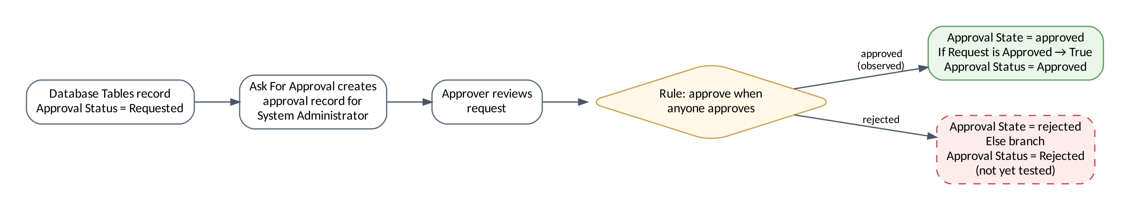
Figure 8: Approval decision flow

4.3.9 Email notification configuration and limitations
The Send Email action uses the subject 'Network Request Received - Pending Approval' and this body:
Hello,
Your Network Request has been received successfully.
Your request is now pending approval. We will notify you once it is reviewed.
Thank you for contacting us.
Network Team
Table 16: Email notification status
Aspect | Observed (Screenshot 10)
Email record generated | Yes — Type send-ready; Target Database Tables: DAT0001016; created 2026-10-19 09:42:16
Generated by the flow | Yes — header X-ServiceNow-Source: FlowDesigner
Subject, body and recipient populated | Yes (recipient redacted in this document)
Notification type | SMTP
Successful external delivery | Not verified — record still send-ready; Email Log has no entries
SMTP configuration | Known limitation — no active SMTP account (owner-reported); configuration required

4.3.10 Request lifecycle and catalog task closure
Figure 9: Request lifecycle
A request is ordered from the catalog (observed: REQ0010004 in My Requests), the flow processes it, and fulfilment happens through a catalog task. SCTASK0010008 (Screenshot 9) is linked to requested item RITM0010004, has the short description 'Provide requested service', and shows State Closed Complete. Its activity log records the change from Pending at 2026-10-19 08:14:33. The mechanism that generates the catalog task is not covered by the evidence.
Evidence timeline (2026-10-19): catalog task closed 08:14:33; email record for DAT0001016 created 09:42:16; flow test run 21:55:26–21:58:24. These are separate activities, not one execution.

4.3.11 Security, access control and data validation
- Users authenticate to ServiceNow; access to forms and records follows the platform's role-based access.
- Approval is restricted to the configured approver (System Administrator). A dedicated approval group is recommended for production.
- No ACLs are listed for u_database_table (Screenshot 5, BG-04); non-admin access has not been tested (TC-21).
- Six catalog variables are mandatory on the form; mobile-number format and the existing-ID requirement are not enforced (TC-19, TC-20).
- No credentials, passwords or tokens are included in this documentation; the email recipient is redacted.

5. PROJECT PLANNING & SCHEDULING

5.1 Project Planning
Table 17: Product backlog and sprint allocation (estimates reconstructed for documentation)
Sprint | Epic | Story | Story points | Priority | Status
Sprint-1 | Catalog Item Setup | USN-1 | 2 | High | Done
Sprint-1 | Catalog Item Setup | USN-2 | 3 | High | Done
Sprint-1 | Catalog Item Setup | USN-3 | 2 | Medium | Done
Sprint-1 | Catalog Item Setup | USN-4 | 2 | High | Done
Sprint-1 | Data Model | USN-5 | 3 | High | Done
Sprint-1 | Data Model | USN-6 | 2 | Medium | Done
Sprint-2 | Flow Automation | USN-7 | 3 | High | Done
Sprint-2 | Flow Automation | USN-8 | 3 | High | Carried over (BG-03)
Sprint-2 | Notification | USN-9 | 2 | Medium | Done
Sprint-2 | Approval | USN-10 | 3 | High | Done
Sprint-2 | Approval | USN-11 | 3 | High | Done
Sprint-3 | Fulfilment | USN-12 | 2 | Medium | Done
Sprint-3 | Testing & Evidence | USN-13 | 3 | High | In progress
Sprint-3 | Documentation & Demo | USN-14 | 3 | Medium | In progress

Table 18: Project tracker
Sprint | Total SP | Duration | Start | End (planned) | SP completed
Sprint-1 | 14 | [N days] | [date] | [date] | 14
Sprint-2 | 14 | [N days] | [date] | [date] | 11 (USN-8 carried over)
Sprint-3 | 8 | [N days] | [date] | [date] | 2 (in progress)

Velocity = completed story points / completed sprints = (14 + 11) / 2 = 12.5 story points per sprint. Average velocity per day = 12.5 / D, where D is the sprint duration in days (sprint dates were not recorded).
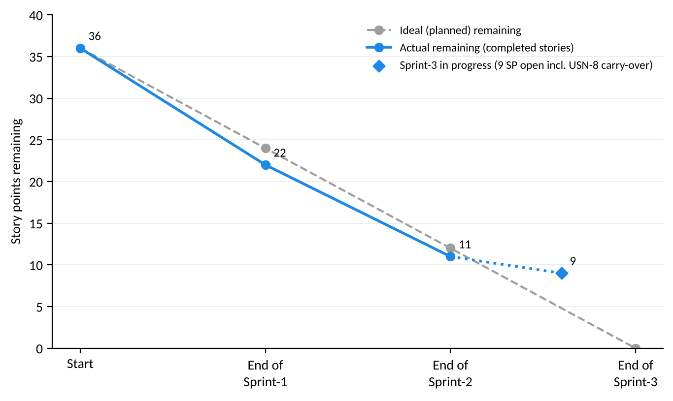
Figure 10: Burndown chart

6. FUNCTIONAL AND PERFORMANCE TESTING

6.1 Performance Testing
Testing was manual, on the developer instance, using the System Administrator account. Evidence comes from the Service Portal, the catalog form, the UI Policy and table definitions, the flow and its execution details, the Database Tables list, the catalog task and the outbound email record (Screenshots 1–10).
The only performance data available is the per-step duration from one Flow Designer test run (Screenshot 7). It is a single observation, not a load test. Form load time (PT-01) and multiple submissions (PT-03) have not been measured.
Table 19: Flow execution durations — test run on 2026-10-19 (Screenshot 7)
Step | State | Start time | Duration
Flow (overall statistics) | Completed | 21:55:26 | 3633 ms
1 Get Catalog Variables | Completed | 21:55:26 | 98 ms
2 Create Record | Completed | 21:55:26 | 152 ms
3 Send Email | Completed | 21:55:26 | 925 ms
4 Ask For Approval | Completed | 21:55:27 | 2155 ms
5 If Request is Approved | Evaluated — True | 21:58:24 | 288 ms
6 Update Record | Completed | 21:58:24 | 288 ms
7 Else / 8 Update Record | Not Run | — | —

The approval decision was recorded at 21:58:24, about three minutes after Ask For Approval started (21:55:27). End-to-end time is therefore dominated by the approver's response, not by processing time.

6.2 Functional Test Cases
Results: 24 test cases — Pass 11, Fail 1, Requires Verification 4, Not Tested 8.
Table 20: Functional and performance test cases (full steps in the testing deliverables)
ID | Scenario | Expected Result | Actual Result | Status | Evidence
TC-01 | Catalog item availability | Item available with description 'Network Services Request'; form opens. | Network Request shown in Popular Items with 'Network Services Request'; form opens at Network > Network Request. | Pass | Screenshots 1, 3
TC-02 | Request submission | Request record generated with a request number. | My Requests lists REQ0010004, REQ0010003 and REQ0010002 for Network Request. | Pass | Screenshot 1
TC-03 | Existing-ID field shown for Existing | 'Enter your existing id' becomes visible. | Field visible when Existing is selected. | Pass | Screenshots 3, 4
TC-04 | Existing-ID field hidden for New | 'Enter your existing id' is not shown. | Field not shown when New is selected. | Pass | Screenshot 2
TC-05 | Variable set: Email and User Name auto-population | Email and User Name are populated from the referenced user. | Reported as populated by the tester; no screenshot captured (Screenshots 2 and 3 show the fields before a user is selected). | Requires Verification | Tester observation only
TC-06 | Variable set: Phone Number auto-population | Phone Number is populated when the user record holds a phone value. | Phone Number did not populate for the System Administrator account. | Requires Verification | BG-01
TC-07 | Flow trigger on catalog item request | Flow starts on the Service Catalog trigger. | Trigger 'Service Catalog'; execution shows 'Catalog Item Requested' (Test Run — Completed). | Pass | Screenshots 6, 7
TC-08 | Get Catalog Variables | Step completes and outputs the submitted variable values. | Completed in 98 ms; output pills defined for all variables. Output values not shown in the screenshots. | Requires Verification | Screenshots 6, 7
TC-09 | Create Record stores submitted values | Each field holds the value entered on the form. | Records created by the flow hold the literal variable names (address, mobile_number, requested_for, total_amount, mode_of_payment, type_of_connection) and Database Number = 'Trigger → Service Catalog → Requested It…'. | Fail | Screenshot 8; BG-03 (recommended fix not yet applied or retested)
TC-10 | Email record generation and content | Email record with subject 'Network Request Received - Pending Approval', configured body and recipient. | Email record generated (Target DAT0001016, Flow Designer source); subject, body and recipient populated; Type send-ready. | Pass | Screenshot 10
TC-11 | External email delivery | Email delivered to the recipient inbox. | Not verified. Record remains send-ready; Email Log has no entries; owner reports that no active SMTP account is configured. | Requires Verification | Screenshot 10; BG-02
TC-12 | Ask For Approval | Approval requested; flow continues after the decision. | Step 4 Completed; flow resumed at 21:58:24 after the decision. | Pass | Screenshot 7
TC-13 | Approval condition evaluation | Condition evaluates True when approved. | Evaluated — True. | Pass | Screenshot 7
TC-14 | Approved branch record update | Approval Status = Approved. | Step 6 Update Record Completed. Record DAT0001015 was observed with Approval Status = Approved (owner observation); a flow-created record with Approval Status = Approved is visible in Screenshot 8. | Pass | Screenshots 7, 8
TC-15 | Rejected branch record update | Else branch runs and Approval Status shows Rejected. | Not executed (Else and step 8 Not Run in the test run). | Not Tested | Screenshot 7
TC-16 | Approval Request related list | Only approvals with matching source_table and document_id are listed. | Not executed. | Not Tested
TC-17 | Catalog task closure | Task saved with State Closed Complete. | SCTASK0010008 is Closed Complete (changed from Pending on 2026-10-19 08:14:33); linked to RITM0010004. | Pass | Screenshot 9
TC-18 | Mandatory-field validation | Submission blocked with messages. | Not executed. Six variables are marked mandatory (*) on the form. | Not Tested | Screenshot 3
TC-19 | Mobile number format validation | Invalid number rejected. | Not executed. | Not Tested
TC-20 | Existing ID required for Existing | Submission blocked. | Not executed. The UI Policy action sets Mandatory = Leave alone, so the field is not made mandatory. | Not Tested | Screenshot 4
TC-21 | Access control on Database Tables | Unauthorised access prevented. | Not executed. No ACLs are listed for u_database_table. | Not Tested | Screenshot 5; BG-04
PT-01 | Catalog form load time | Form loads within an agreed target. | Not measured. | Not Tested
PT-02 | Flow step durations | Duration recorded for each automated step. | One test run: Get Catalog Variables 98 ms; Create Record 152 ms; Send Email 925 ms; Ask For Approval 2155 ms; If 288 ms; Update Record 288 ms; flow statistics 3633 ms. Single observation, not a load test. | Pass | Screenshot 7
PT-03 | Multiple submissions | Each request processed without errors. | Not executed. | Not Tested

6.3 Defects
Table 21: Open defects
Bug ID | Description | Severity | Status
BG-01 | Phone Number in the Requester Information variable set did not populate for the System Administrator account. | Medium | Open
BG-02 | Notification email is generated but not delivered; the record stays send-ready and the Email Log is empty. | High | Open
BG-03 | Create Record stores literal variable names (e.g. 'address', 'mobile_number') and the trigger pill path in Database Number instead of the submitted values. | High | Open
BG-04 | No access controls (ACLs) are listed for the custom table u_database_table. | Medium | Open
BG-05 | Approval Status is a free-text String; observed values are inconsistent (Pending, Approved, requested). | Low | Open
BG-06 | The list filter 'Database Number >= DAT0001015' does not select records by DAT number, because Database Number is a custom String field and DAT numbers are stored in the Number field. | Low | Open

The list filter 'Database Number >= DAT0001015' visible in Screenshot 8 is applied to the custom Database Number field, not to the Number field that holds DAT numbers (BG-06). It is therefore not evidence that records are missing or that approval failed.

7. RESULTS

7.1 Output Screenshots
All screenshots are actual captures from the developer instance. They were cropped for readability; on the widest screens only the empty middle area was removed, and the email recipient was redacted. No values were altered. Screenshots 1–6 appear with the implementation sections they evidence; the run-time outputs follow below.
Table 22: Screenshot evidence index
No. | Shows | Location | Supports
1 | Catalog item availability; submitted requests | Report 4.3.3 | TC-01, TC-02
2 | UI Policy behaviour (New) | Report 4.3.4 | TC-04
3 | UI Policy behaviour (Existing); variables | Report 4.3.4 | TC-01, TC-03, TC-18
4 | UI Policy configuration | Report 4.3.4 | TC-03, TC-20
5 | Custom table structure | Report 4.3.5 | TC-21
6 | Flow configuration | Report 4.3.7 | TC-07, TC-08
7 | Flow execution evidence | Report 7.1 | TC-07, TC-08, TC-12, TC-13, TC-14, TC-15, PT-02
8 | Database records; approval status; mapping defect | Report 7.1 | TC-09, TC-14
9 | Catalog task closure | Report 7.1 | TC-17
10 | Notification record | Report 7.1 | TC-10, TC-11

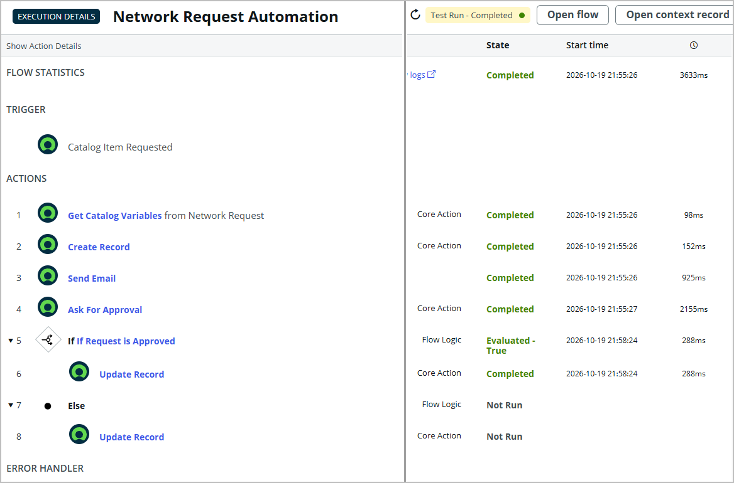
Screenshot 7: Flow execution details — Test Run Completed; Catalog Item Requested; steps 1–6 Completed; 'If Request is Approved' Evaluated — True; Else Not Run (empty middle columns removed)
Result: the flow ran from the Service Catalog trigger through all automated steps, the approval condition evaluated True, and the approved branch updated the record. The Else branch did not run.
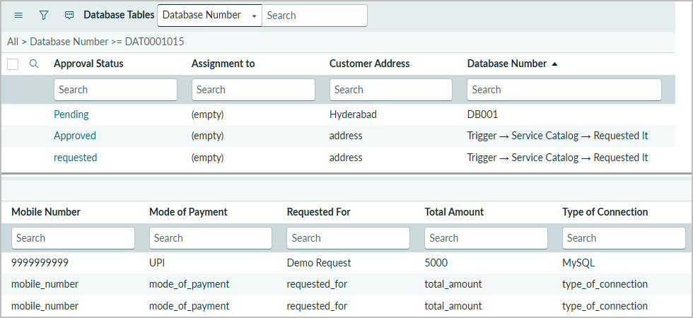
Screenshot 8: Database Tables list — Approved and requested records created by the flow (columns shown in two parts)
Result: the flow created Database Tables records and the approved branch set Approval Status = Approved. However, the request fields contain the variable names ('address', 'mobile_number', …), and Database Number contains the trigger pill path, instead of the values entered on the form. This is defect BG-03 (TC-09 Fail). The first row (Pending, Hyderabad, DB001, 9999999999, UPI, Demo Request, 5000, MySQL) contains entered values rather than variable names; whether it was created manually or by an earlier version of the flow cannot be established from the screenshot.
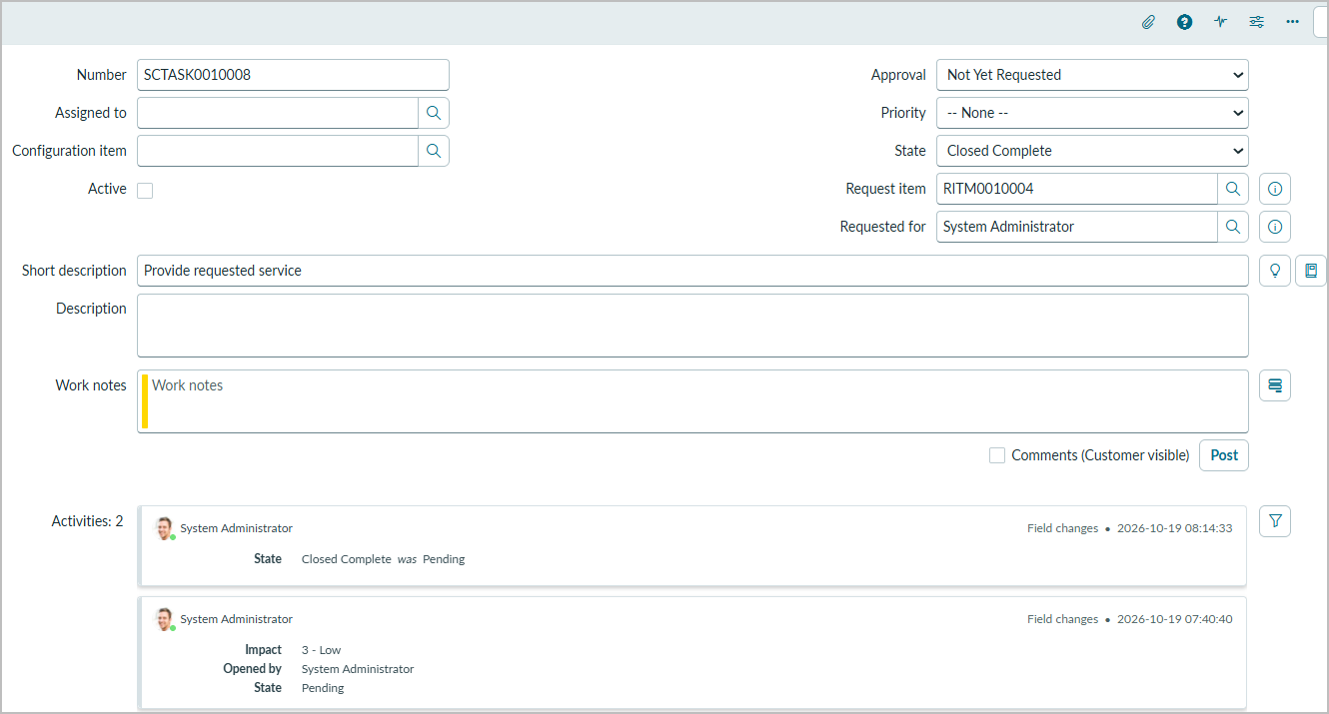
Screenshot 9: Catalog task SCTASK0010008 — State Closed Complete; Request item RITM0010004
Result: the catalog task for RITM0010004 was closed with State Closed Complete.
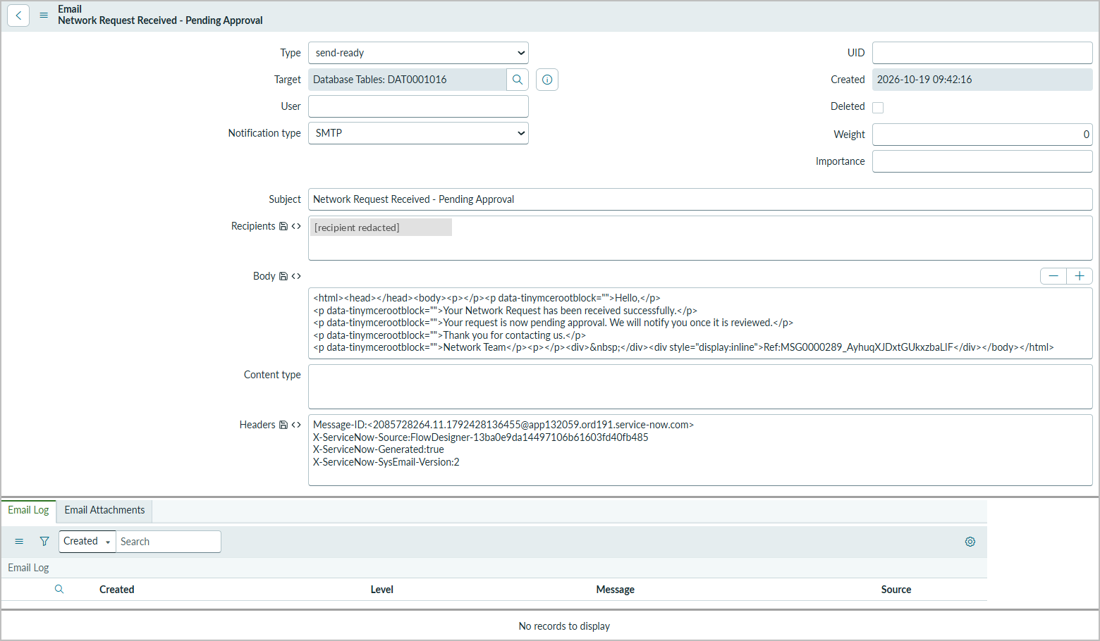
Screenshot 10: Email record 'Network Request Received - Pending Approval' — Type send-ready, Target DAT0001016, source Flow Designer; Email Log empty (recipient redacted)
Result: the notification record was generated by Flow Designer for DAT0001016 with the configured subject and body. Its Type is send-ready and the Email Log is empty, so delivery to the recipient is not verified.

8. ADVANTAGES & DISADVANTAGES
Advantages
- Single, structured intake channel through the Service Catalog and Service Portal.
- Only relevant fields are shown (UI Policy), and mandatory fields are enforced on the form.
- The flow starts automatically when the item is requested and runs each automated step in milliseconds.
- Every request creates a Database Tables record with an approval status.
- Approval routing is automated in Flow Designer with a clear decision branch.
- An acknowledgement email record is generated automatically.
- Each run is traceable through Flow Designer execution details.
- Built with low-code platform features, so it is easy to maintain and extend.
Disadvantages / limitations
- The record mapping defect means stored data does not yet reflect the submitted values.
- Email delivery depends on an SMTP configuration that is not yet in place.
- A single configured approver (System Administrator) is a bottleneck and not realistic for production.
- The rejected branch, validation, security and load are not yet tested; the custom table has no ACLs.
- Built in the Global scope on a developer instance, which is not ready for production deployment.

9. CONCLUSION
The project delivers a working ServiceNow configuration for network service requests. It provides a Network Request catalog item with mandatory fields and a UI Policy that shows the existing-ID field only for Existing connections, and a custom Database Tables table. A Service Catalog-triggered Flow Designer flow creates the record, generates an acknowledgement email record, requests approval and updates the status. A Flow Designer test run completed every automated step in milliseconds, evaluated the approval condition as True and updated the record to Approved; the catalog task was closed as Closed Complete.
The screenshots also exposed issues, reported plainly here: the Create Record mapping stores variable names instead of the submitted values (BG-03); email delivery is not verified because SMTP is not configured (BG-02); the custom table has no ACLs (BG-04); Phone Number does not populate (BG-01); and the rejected branch, validation, security and load tests remain open. Fixing the mapping and configuring SMTP are the next steps before the solution could be considered for a production instance.

10. FUTURE SCOPE
- Fix the Create Record mapping with data pills from Get Catalog Variables and retest (BG-03).
- Configure and validate an SMTP account so notifications are delivered, then retest delivery.
- Add approval and rejection outcome emails to the requester.
- Test the rejected (Else) branch and add flow error handling.
- Add client-side validation for mobile number format and make the existing ID mandatory for Existing connections.
- Define ACLs on the Database Tables table and test with non-admin users.
- Convert Approval Status to a Choice field with consistent values.
- Route catalog tasks to a Network assignment group and add SLAs for turnaround time.
- Build reports and a dashboard of requests by status, connection type and payment mode.
- Package the configuration as a scoped application with an update set for repeatable deployment.

11. APPENDIX

11.1 Source Code (if any)
The solution is configuration-based. The only script is the 'Approval Request' relationship query:
(function refineQuery(current, parent) {
current.addQuery('source_table', parent.getTableName());
current.addQuery('document_id', parent.sys_id);
})(current, parent);
Flow, catalog item, variable set, UI Policy and table configuration are documented in Section 4.3. Project repository: https://github.com/pavan-kalyan-pk-2646/servicenow-network-request-automation.git.

11.2 Dataset Link
Not applicable — no external dataset is used. Test data was entered through the catalog item on the developer instance.

11.3 GitHub & Project Demo Link
Item | Link
GitHub repository | https://github.com/pavan-kalyan-pk-2646/servicenow-network-request-automation.git
Project demo (Drive folder) | https://drive.google.com/drive/folders/1PAaBuybnLuN8JptoJ27fXBuDrTUFdcjM?usp=sharing

On 2026-10-20 the GitHub repository was publicly reachable and contained only README.md; the contents of the demo Drive folder could not be viewed by the documentation author and are not verified here.

11.4 Maintenance and troubleshooting
Table 23: Troubleshooting guide
Symptom | Check / action
Records contain 'address', 'mobile_number' etc. | In Create Record, replace typed text with data pills from step 1 (Get Catalog Variables); retest TC-09 (BG-03).
Email record stays send-ready | Confirm outbound email is enabled and an active SMTP email account exists; review the Email Log; retest TC-11.
Flow does not start | Confirm the flow is Active and its latest version is published (status bar showed Draft), and that requesting Network Request triggers it.
Get Catalog Variables returns empty values | Confirm the step uses the trigger's Requested Item Record and the Network Request catalog item.
Existing-ID field does not show/hide | Check the UI Policy condition, 'Applies on a Catalog Item view', On load and Reverse if false.
Phone Number not pre-filled | Check the referenced user's phone value and how the variable is populated (BG-01).
No approval generated | Check the Ask For Approval approver configuration and that the approver user is active.
List filter returns unexpected records | Filter on Number (DAT…), not on the custom Database Number field (BG-06).
Approvals related list empty | Check the relationship's applies-to/queries-from tables and that the related list is on the form layout.

11.5 Deployment and configuration considerations
- Current state: development instance only; no production deployment.
- Developer instances can hibernate or be reclaimed after inactivity — keep an exported update set or XML backup of the configuration.
- Before promotion: fix the Create Record mapping, configure SMTP, define ACLs, replace the single approver with an approval group, make Approval Status a Choice field, add validation, move to a scoped application and retest every case.
- Promote through an update set (development → test → production) and run the UAT cases in the target instance.

11.6 References
- ServiceNow Product Documentation — https://docs.servicenow.com
- SkillWallet project templates (Ideation, Requirement Analysis, Design, Planning, Development and Documentation phases) supplied for this project.

